……………………………………………………………………………………………………….

The Importance of Understanding
Vortex-Induced Vibration
Most structural failures result from inadequate design, inappropriate materials of construction, or shoddy construction. In many cases, two or more of these factors contribute to failure.
Vortex-induced vibration (VIV) plays an important role in the design of many types of engineered systems. From bridges, to aircraft, to tall buildings, to antennas, and utility lines, VIV is a means by which structures can fail.

Many structures are designed to have very little or no response (e.g., displacement or deformation) under conditions anticipated to occur during the service life of the structure. A key issue, however, is that VIV results from forces due to flow of a fluid (typically air or water), which for many years were not accounted for in many structural designs. As discussed in the video link below, alternate shedding of vortices from opposite sides of the cylinder gives rise to a time-fluctuating force on the cylinder. This structural loading therefore depends on time, and requires a different type of analysis than is needed to deal with other kinds of loading, such as earthquake loading.
https://www.youtube.com/watch?v=Eh_vOcXazaU

Some examples of structures that have either failed, or which undergo significant deformation due to VIV are highlighted in the videos to which links are provided below.
Tacoma Narrows Bridge (__link{https://www.youtube.com/watch?v=KVc7oBKzq9U Click here to watch})
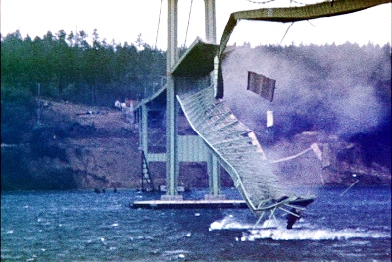
The collapse of the Tacoma Narrows Bridge in 1940 was a dramatic example of how VIV could contribute to destruction of a large civil structure. Theodore von Kármán, who in 1912 first explained the vortex shedding shown in the video link above, played an important role in the post-failure investigation.
Building sway (__link{https://www.youtube.com/watch?v=rlpUhgfEZPU click here to watch})
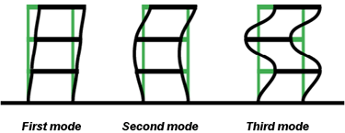
Tall "narrow" buildings are known to deform in high winds, and it is important that the resulting motion not lead to structural collapse. No tall building has collapsed due to wind loading, but a number of other tall civil structures have. Examples include the 1989 collapse of a 195 m (640 ft) tall "solar chimney" in Spain, and the collapse of numerous television and radio transmission towers up to 609 meters (1998 ft) high (see __link{https://en.wikipedia.org/wiki/List_of_catastrophic_collapses_of_broadcast_masts_and_towers wiki list of collapses of broadcast masts and towers})
Aeroelasticity in aerodynamic systems (__link{https://www.youtube.com/watch?v=QD3G86dfj6Y click here to watch})

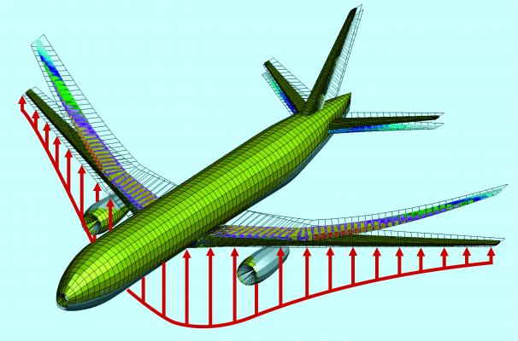
As aircraft move through the atmosphere, they are subjected to a number of forces, including lift and drag. Sometimes these forces create VIV in the wings of the aircraft, more commonly referred to in aeronautics as “aeroelastic flutter”. This phenomenon is very serious, and can cause airplanes to shear themselves apart midflight if not accounted for in the design, as shown in the video above. More commonly, flutter leads to fatigue cracking in flight structures, which can ultimately result in catastrophic failure. An example of flutter induced fatigue cracking was the United States Air Force’s C-5A, designed for 30,000 flight hours, but for which all surviving aircraft needed to be “rewinged” well before 8,000 flight hours because of excessive flutter (http://www.airvectors.net/avc5.html). The interactions between external aerodynamics and structural dynamics in modern aircraft are sufficiently complex that the accurate prediction of flutter characteristics during the design stage is difficult. Thus, there is considerable interest in developing design tools and methodologies that can predict, control, and suppress flutter long before an aircraft is built and tested.

“Cable Galloping” (__link{https://www.youtube.com/watch?v=8PaHcoiFUOg click here to watch})

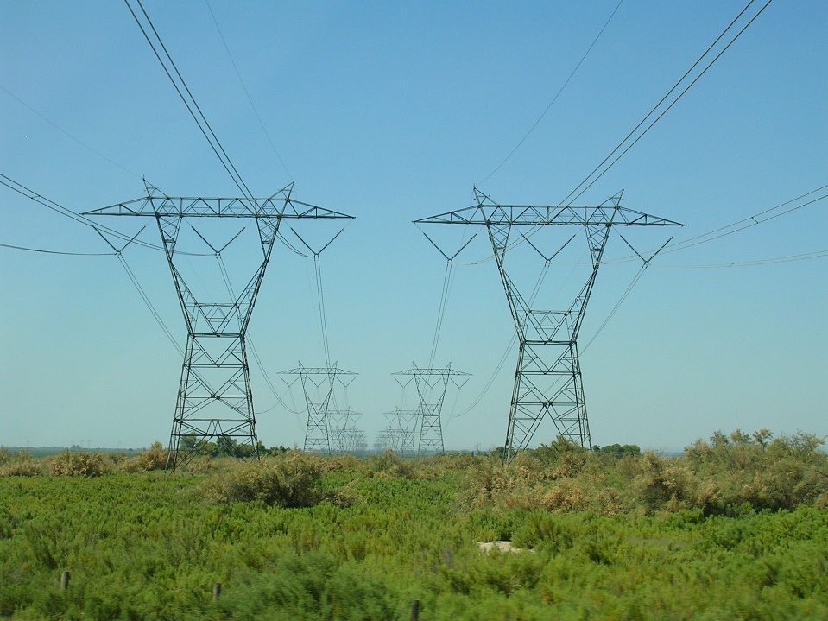
Similar to aeroelastic flutter, “cable galloping” (or “conductor gallop”) occurs due to the interaction of lift and drag forces being exerted on power transmission lines on windy days. If left uncontrolled, excessive cable galloping can cause severe damage to power lines, even causing them to snap and fall to the ground.

……………………………………………………………………………………………………….

The relationship between the Karman vortex street and the VIV that led to failure of the bridge has been the subject of some debate. See Steven Ross, et al. "Tacoma Narrows 1940." In Construction Disasters: Design Failures, Causes, and Prevention. McGraw Hill, 1984, pp. 216–239

